New Product Release 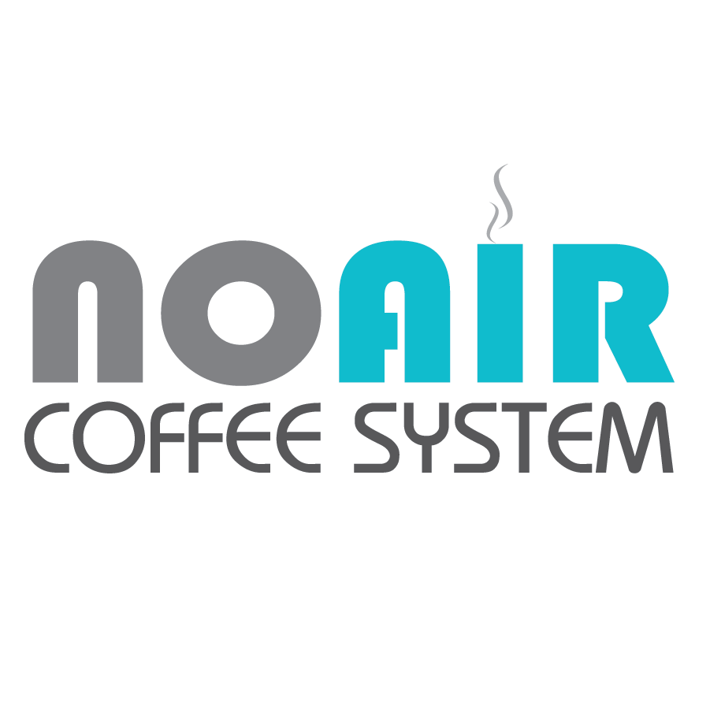
________________________________________________________
For Immediate Release
No Air Coffee, LLC
October 22, 2021

Coffee Discovery The World Has Been Waiting For
NoAir Coffee System's full immersion vacuum brewing process uses science technology to brew delicious coffee that is easier on the stomach.

Springfield, MO. October 20, 2021 - New Product Release-
NoAir Coffee System
The NoAir Coffee System's vacuum technology removes trapped carbon dioxide which opens the way for full flavor extraction, while at the same its full immersion process prevents the formation of stomach churning carbonic acid (look up: "carbonic acid for vomiting"). Thus making the NoAir Coffee System a coffee brewer that brews more flavorful coffee that many say is easier on the stomach.
About NoAir Coffee System
Half of the human race is in a relationship with coffee. Some simply count on their daily fix, but for the many in love with coffee, it can be an unsettling arrangement, at times even bitter. Going without can be depressing. Yet, getting together can mean bees instead of butterflies, and aftertaste instead of afterglow. Why does it have to be so complicated?
The inventor, Tony Dodd, discovered the process while trying to create a better cold brewer. “My relationship with hot brew had hit rock bottom, so I pursued cold brew as a way to stay in the game. The process worked well with cold brew, so I tried it with hot brew, and that changed everything. It’s the best of both worlds; the smoothness of cold brew, with all the amazing flavors available in hot brew! I like to say that NoAir Coffee is the only coffee that loves you back!"
Since coffee brewing has been unchanged for hundreds of years, the NoAir Coffee System is radically making changes, shaking things up and vacuuming things out. It really is a coffee brewer for the 21st Century. The NoAir Coffee System has launched on Kickstarter on 11/28/21, will receive the bulk of product in mid December 2021, sell product on its website in December, and sell on Amazon by January 2022. The NoAir company has plans to get the NoAir Coffee System on store shelves in 2022, bottle their product in the near future, and sell their own brand of specialty coffee beans as well.

NoAir Coffee, LLC
PO Box 1421
Nixa, MO 65714
Info@Noaircoffee.com
https://www.noaircoffee.com/

# # #

